COLONEL TODD M. GRAHAM, P.E.

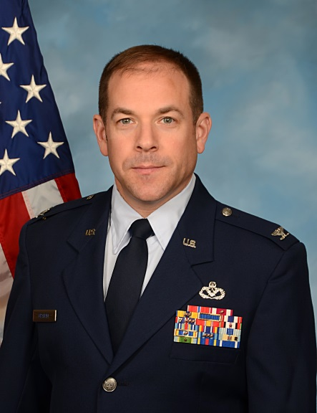
Colonel Todd M. Graham is the Deputy Commander, 235th Civil Engineer Flight, Warfield Air National Guard Base, Martin State Airport, Baltimore MD.

Colonel Graham entered the Air Force in 1996 as a Distinguished Graduate of the Reserve Officer Training Corps program through Vanderbilt University in Nashville, TN, where he majored in civil and environmental engineering. Upon graduation, Colonel Graham completed graduate school studies at Clemson University through the prestigious Air Force Institute of Technology (AFIT) Civilian Institute program. While in graduate school he served as the AFIT liaison officer to the Clemson Air Force ROTC detachment commander. He graduated from Clemson in 1998 with a Master’s Degree in environmental engineering.

Colonel Graham held many positions during his active duty career. At Randolph AFB, he served as the Deputy Housing Director, Environmental Program Manager and Deputy Engineering Flight Chief. While at Andrews AFB, he initially served as the Deputy Engineering Flight Chief and then transitioned to his last active duty position as the Chief of Maintenance Engineering. During his tour at Andrews AFB, Colonel Graham deployed to Yongsan Army Garrison in Korea to support the Joint Engineer Cell during the annual exercise Ulchi Focus Lens. Major Graham also deployed to Al Udeid Air Base (AB), Qatar, in June 2002 to support Operation ENDURING FREEDOM as a part of Prime BEEF team. While at Al Udeid AB, he served as the Engineering Flight Chief and was responsible for all planning, programming, design, and construction of US facilities on Al Udeid AB. During this deployment, Colonel Graham worked closely with members of the 235 CEF supporting their mission to design and construct what would ultimately become the Combined Air Operations Center for the AOR.

Upon separating from active duty in December 2003, Colonel Graham joined the Maryland Air National Guard as a member of the 235 CEF. He has served in numerous roles with the 235 CEF, including executive officer to unit commander. In 2010, Colonel Graham deployed to Camp Leatherneck, Afghanistan, in support of Operation ENDURING FREEDOM, where he served as the contract construction lead for 2nd Marine Expeditionary Brigade and 1st Marine Expeditionary Force (Forward). Currently he is the Deputy Commander for external customer support directly responsible for the delivery of engineering capability and command and control support to the Office of the Joint Chief of Staff, Headquarters Air Force Director of Civil Engineers, Headquarters United States Air Forces in Europe, and Headquarters European Command.

In his civilian career, Colonel Graham is a Senior Associate in Booz Allen Hamilton’s Defense Infrastructure & Military Health Team based in McLean, VA, as a civil and environmental engineer. He provides facilities planning and management and environmental management support to multiple clients across the Department of Defense and Federal sector, primarily focusing on US Air Force organizations at the headquarters, major command and installation levels. His clients at Booz Allen have included Headquarters Air Force Director of Civil Engineers, the Army’s Installation Management Command, the Air Force Civil Engineer Center, Pacific Air Forces, U.S. Marine Corps, National Science Foundation, and the Environmental Protection Agency.

EDUCATION
1996, Bachelor of Engineering, Civil & Environmental Engineering, Vanderbilt University
1998, Master of Engineering, Environmental Engineering, Clemson University
2001, Squadron Officer School, Maxwell AFB, AL
2010, Air Command and Staff College (non-residence), Maxwell AFB, AL
2015, Air War College (non-residence), Maxwell AFB, AL

CERTIFICATIONS
Registered Professional Civil Engineer in Tennessee, 2002
Certified Facility Manager (International Facility Management Association)
Sustainability Facility Professional (International Facility Management Association)

ASSIGNMENTS
1. August 1996 – June 1998, graduate student, Clemson University, Air Force Institute of Technology Civilian Institute Program
2. June 1998 – July 2001, Civil Engineer Officer, Randolph Air Force Base, TX
3. July 2001 – December 2003, Civil Engineer Officer, Andrews Air Force Base, MD
4. January 2004 – July 2016, Civil Engineer Staff Officer, 235th Civil Engineer Flight, Baltimore, MD
5. July 2016 – Present, Deputy Commander, 235th Civil Engineer Flight, Baltimore, MD

MAJOR AWARDS AND DECORATIONS
Bronze Star
Air Force Meritorious Service Medal with 2 oak leaf clusters
Air Force Commendation Medal with 2 oak leaf clusters
Distinguished/Presidential Unit Citation
Air Force Outstanding Unit Award with Valor Device
National Defense Service Medal
Afghanistan Campaign Medal
Global War on Terrorism Expeditionary Medal
Global War on Terrorism Service Medal
Air Force Expeditionary Service Ribbon with Gold Border

EFFECTIVE DATES OF PROMOTIONS
Second Lieutenant 28 June 1996
First Lieutenant 28 June 1998
Captain 28 June 2008
Major 21 September 2004
Lieutenant Colonel 4 December 2010
Colonel 15 September 2016

