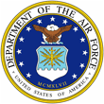 |  | 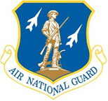

LIEUTENANT COLONEL JOHN J. DEVINE, P.E., P.M.P.
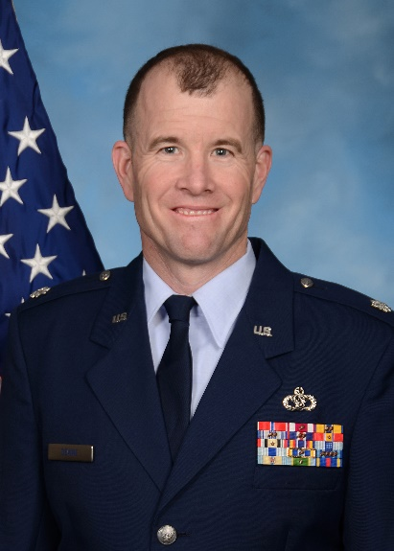
Lieutenant Colonel John J. Devine is the EUCOM support branch chief with the 235th Civil Engineer Flight, Warfield Air National Guard Base, Martin State Airport, Baltimore MD.

Lt Col Devine was born in San Francisco, California and graduated with a degree in Civil Engineering from Santa Clara University in 1993. He was commissioned in 1995 through Officer Training School (OTS) at Maxwell AFB, AL.

Lt Col Devine began his career on active duty at Randolph AFB, where he served as the Chief of Environmental Compliance. While at Elmendorf AFB, he was responsible for construction and maintenance at all of the remote radar sites and forward operating locations in Alaska. Next at Davis-Monthan, Lt Col Devine managed the NEW HORIZONS exercise program for SOUTHAF and oversaw a $90M MILCON program at Curacao and Ecuador. During this time, Lieutenant Col Devine deployed to Cairo, Egypt and Baghdad, Iraq in support of OPERATION IRAQI FREEDOM. He served as a deployed squadron commander and had the honor of leading the Air Force’s first civil engineer squadron in Iraq. While in Iraq, he stood up Camp Sather AB and supported JSOC.

Lt Col Devine separated from active duty in March 2004 and joined the 307th RED HORSE squadron as a member of the USAFR. He served as the chief of operations and the chief of engineering. During his time there, he deployed in support of SOUTHCOM to Guatemala where his team built schools and medical clinics. Additionally, he led the effort to build a $2M convoy training site at Camp Bullis, TX. In 2007, Lt Col Devine joined the 235th Civil Engineer Flight, Maryland Air National Guard. During his time as civil engineer staff officer with the 235th, he supported numerous construction projects in Israel, Lithuania, Latvia, Ukraine, Bulgaria, Moldova, Albania, Estonia, Bosnia, Georgia, Hungary, Romania, Armenia, and Azerbaijan. Lt Col Devine deployed to Iraq again in 2010. While deployed to Iraq, he commanded a 100 person construction team that was responsible for all outside the wire troop construction in Iraq. In 2013, Lt Col Devine became the EUCOM support branch chief for the 235th CEF. In this capacity, he has deployed several times to the EUCOM staff and has served as both humanitarian civic assistance (HCA) and exercise related construction (ERC) program manager for EUCOM. He also helped plan the $100M ERI and EDI programs for EUCOM.

In his civilian career, Lt Col Devine is a GS-15 and Chief of Engineering for the Defense Threat Reduction Agency (DTRA) at Fort Belvoir, VA. He is the primary advisor to the agency director on all facility and engineering issues and he oversees their worldwide facility program. He previously served as the Area Engineer for the National Capital Region for the Army Corps of Engineers. In that role, he directly managed $900M worth of construction between 2008-2017.

EDUCATION
1993, Bachelor of Engineering, Civil Engineering, Santa Clara University
2000, Master of Civil Engineering, University of Alaska
2002, Squadron Officer School, Maxwell AFB, AL
2006, Air Command and Staff College (non-residence), Maxwell AFB, AL
2013, Air War College (non-residence), Maxwell AFB, AL

CERTIFICATIONS
Registered Professional Civil Engineer (PE), Alaska 1999
Project Management Professional (PMP), 2010
US Army Contracting Officer, 2009
DAWIA Level 2 Contracting, 2009
Army Acquisition Corps, 2009

ASSIGNMENTS
1. March 1995 – January 1997, Environmental Program Manager, Randolph Air Force Base, TX
2. January 1997 – July 2000, Civil Engineer Officer, Elmendorf AFB, AK
3. August 2000 – March 2004, Staff Civil Engineer, Davis-Monthan AFB, AZ
4. March 2004 – March 2005, Chief of Engineering, 307th RED HORSE, Lackland AFB, TX
4. March 2005 – November 2007, Chief of Operations, 307th RED HORSE, Lackland AFB, TX
5. November 2007– December 2012, Civil Engineer Staff Officer, 235th CEF, Baltimore, MD
6. January 2013– Present, EUCOM Support Branch Chief, 235th CEF, Baltimore, MD

MAJOR AWARDS AND DECORATIONS
Bronze Star
Air Force Meritorious Service Medal with 2 oak leaf clusters
Air Force Commendation Medal with 2 oak leaf clusters
Air Force Achievement Medal with 2 oak leaf clusters
Air Force Outstanding Unit Award with 2 oak leaf clusters
National Defense Service Medal
Iraq Campaign Medal with 1 oak leaf cluster
Global War on Terrorism Service Medal
Air Force Expeditionary Service Ribbon with Gold Border

EFFECTIVE DATES OF PROMOTIONS
Second Lieutenant 17 March 1995
First Lieutenant 17 March 1997
Captain 17 March 1999
Major 21 June 2004
Lieutenant Colonel 21 June 2012

